Design and configure the hub network using cisco packet tracer

Aim:

To design and configure a LAN using one Hub and five PCs in Cisco Packet Tracer using Class A IP addresses.

Procedure
- Open Cisco Packet Tracer
- Drag and place 1 Hub from Network Devices
- Drag and place 5 PCs from End Devices
- Connect each PC to the Hub using Copper Straight-Through cables
- Click on PC1 → Desktop → IP Configuration
- Assign Class A IP addresses as follows:
  - PC1: 10.0.0.1
  - PC2: 10.0.0.2
  - PC3: 10.0.0.3
  - PC4: 10.0.0.4
  - PC5: 10.0.0.5
  - Subnet Mask (all PCs): 255.0.0.0
- Close IP configuration window after assigning IPs
- Open Command Prompt on any PC
- Use the ping command to ping another PC’s IP address
- Verify that reply is received

DIAGRAM

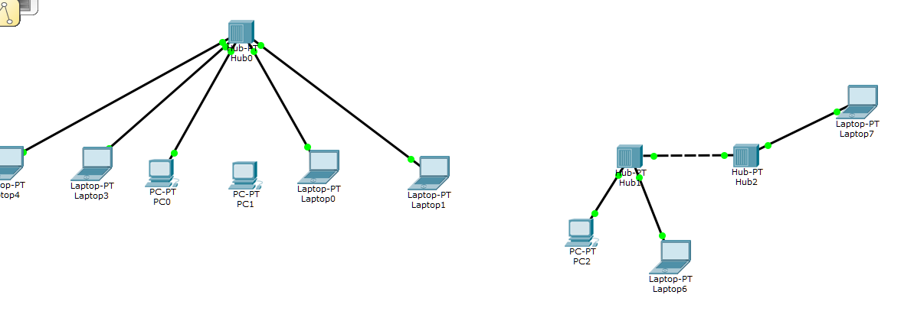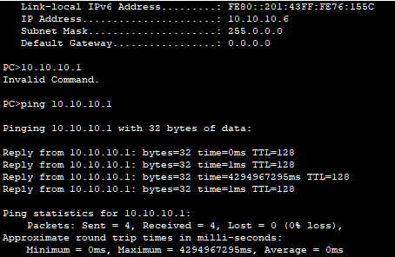

OBSERVATION:
- All five PCs were properly connected to the hub.
- Class A IP addresses were assigned correctly to each PC.
- Same subnet mask was used for all PCs.
- The hub successfully allowed communication between all PCs.
- Ping command showed reply messages between PCs.
- This confirms that the LAN was configured correctly and is working properly.

Result:

The LAN using a hub and five PCs was successfully configured, and network connectivity was

verified using the ping command.

